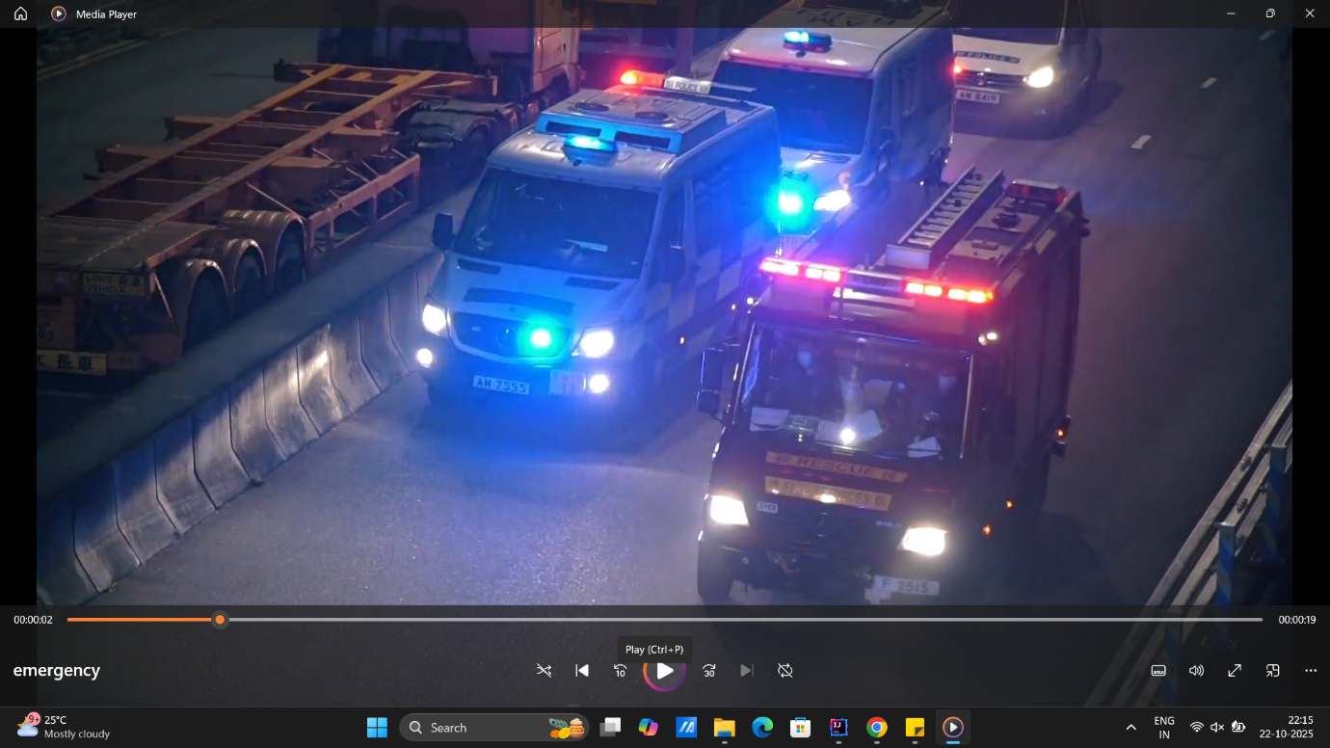

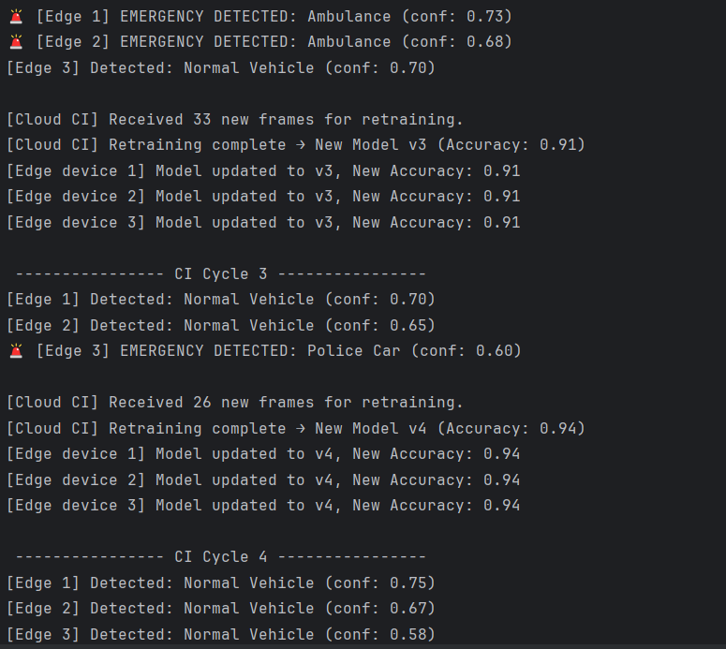
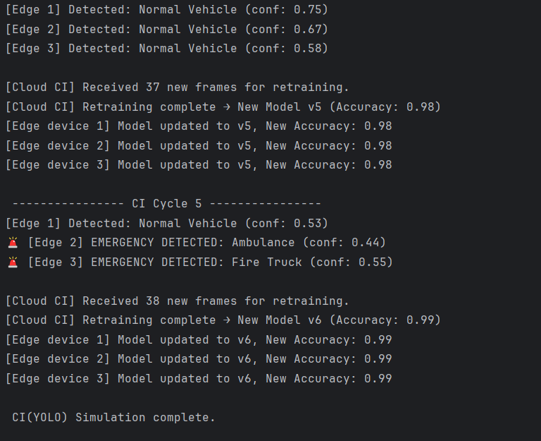

import random
import time
from ultralytics import YOLO
import cv2
import logging
# ------------------ CONFIG ------------------
logging.getLogger("ultralytics").setLevel(logging.ERROR)
# ------------------ EDGE DEVICE ------------------
class EdgeDevice:
def __init__(self, id, model_path='yolov8n.pt'):
self.id = id
self.model_version = 1
self.model = YOLO(model_path) # load YOLOv8 (COCO)
self.detection_accuracy = 0.85
self.data_collected = 0
def run_detection(self, frame=None):
"""Run YOLO detection on a frame and mark possible emergency vehicles."""
if frame is None:
print(f"[Edge {self.id}] No frame -> skipping detection.")
return "None", 0.0
results = self.model(frame)
boxes = results[0].boxes
detected, confidence = "None", 0.0
for box in boxes:
cls_id = int(box.cls[0].item())
conf = float(box.conf[0].item())
label = self.model.names[cls_id]
# Treat vehicle classes as emergency vehicles
if label.lower() in ["car", "truck", "bus", "motorcycle"]:
if random.random() < 0.25: # 25% chance
detected = random.choice(["Ambulance", "Fire Truck", "Police Car"])
else:
detected = "Normal Vehicle"
confidence = conf
break
# simulate accuracy fluctuation
noise = random.uniform(-0.02, 0.02)
self.detection_accuracy = max(0.50, min(0.99, self.detection_accuracy + noise))
self.data_collected += random.randint(5, 15)
# console output
if detected in ["Ambulance", "Fire Truck", "Police Car"]:
print(f"🚨 [Edge {self.id}] EMERGENCY DETECTED: {detected} (conf: {confidence:.2f})")
else:
print(f"[Edge {self.id}] Detected: {detected} (conf: {confidence:.2f})")
return detected, confidence
def send_data_to_cloud(self):
"""Send newly collected data for retraining."""
data_packet = {"edge_id": self.id, "frames": self.data_collected}
self.data_collected = 0
return data_packet
def receive_new_model(self, new_accuracy, new_version):
"""Receive retrained model via CI pipeline."""
self.model_version = new_version
self.detection_accuracy = new_accuracy
print(f"[Edge device {self.id}] Model updated to v{new_version}, New Accuracy: {new_accuracy:.2f}")
# ------------------ CLOUD CONTROLLER ------------------
class CloudController:
def __init__(self):
self.version_counter = 1
self.global_accuracy = 0.85
def aggregate_data(self, packets):
total_frames = sum(p["frames"] for p in packets)
print(f"\n[Cloud CI] Received {total_frames} new frames for retraining.")
return total_frames
def retrain_model(self, data_count):
"""Simulate retraining based on data volume."""
improvement = min(0.05, data_count / 1000)
new_acc = round(min(0.99, self.global_accuracy + improvement), 2)
self.version_counter += 1
self.global_accuracy = new_acc
print(f"[Cloud CI] Retraining complete → New Model v{self.version_counter} "
f"(Accuracy: {new_acc:.2f})")
return new_acc, self.version_counter
def deploy_model(self, edges, acc, version):
"""Push new model to all edge devices."""
for e in edges:
e.receive_new_model(acc, version)
# ------------------ MAIN SIMULATION LOOP ------------------
if __name__ == "__main__":
print("Starting Edge Layer YOLO-CI Simulation...\n")
edges = [EdgeDevice(i) for i in range(1, 4)]
cloud = CloudController()
cap = cv2.VideoCapture("emergency.mp4") # replace with webcam 0
for cycle in range(1, 6):
print(f"\n ---------------- CI Cycle {cycle} ----------------")
for edge in edges:
for _ in range(1):
ret, frame = cap.read()
if not ret:
frame = None
edge.run_detection(frame)
packets = [e.send_data_to_cloud() for e in edges]
total = cloud.aggregate_data(packets)
new_acc, new_ver = cloud.retrain_model(total)
cloud.deploy_model(edges, new_acc, new_ver)
time.sleep(1)
cap.release()
print("\n CI(YOLO) Simulation complete.")

